## Lesson 22 – Activity Sheet

## Getting Started

* **Embedded systems** are small computer systems that have been built into a specific device to perform a single or range of tasks dedicate to a single function.
* Examples of embedded systems include washing machines, navigational devices and TVs

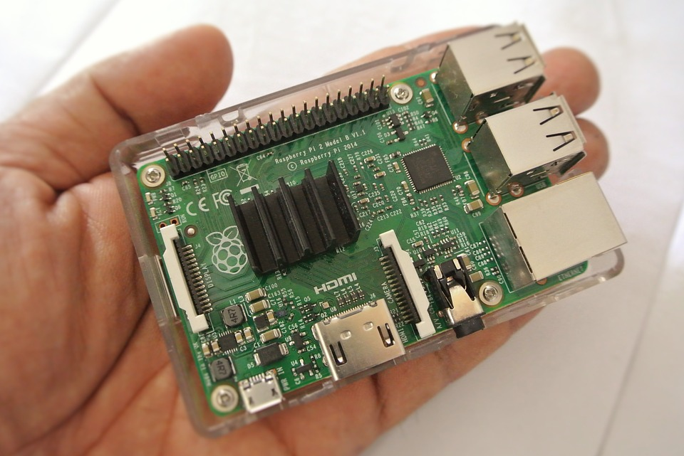

List some examples of embedded systems you are familiar with and the main purpose of the onboard computer system.

|  |  |
| --- | --- |
| **Embedded System** | **Job** |
| Washing Machine | * Enable correct amount of wash powder and water in * Heat water to specific temperature * Spin drum for specific time at specific speed |
| Sat Nav | * Store and display map * Display current position * Calculate best route between two points * Output verbal commands at the correct time * Monitor and re-route |
|  |  |
|  |  |
|  |  |
|  |  |

## Success Criteria

* Identify some examples of embedded systems
* Create examples of code in both block and text-based languages
* Produce **functional** algorithms using block code
* Identify the benefits and disadvantages of both block and text-based coding

## Pro-tip

## When using text code, spacing and spelling is important. When you get errors look for spelling mistakes, missing speech marks or incorrect spacing

## Test Time

## Does your block function display the result of the cubed value?

## What happens if you change the text code calculation to volume = side ** 3? What can you infer from this?

## What happens if you change the text code display.scroll() to display.show()

## Stretch Tasks

* Use blocks to create a function to display the area of a circle
* Use text to create the same function
* Describe in your words the advantages and disadvantages of each method, citing examples
* Create a function that drives and turns to motors to follow a particular route

## Final Thoughts

* During today’s lesson we have looked at embedded systems and the advantages and disadvantages of different programming techniques
* You have demonstrated your understanding of functional programming and developed some functional programs using both block and text-based languages